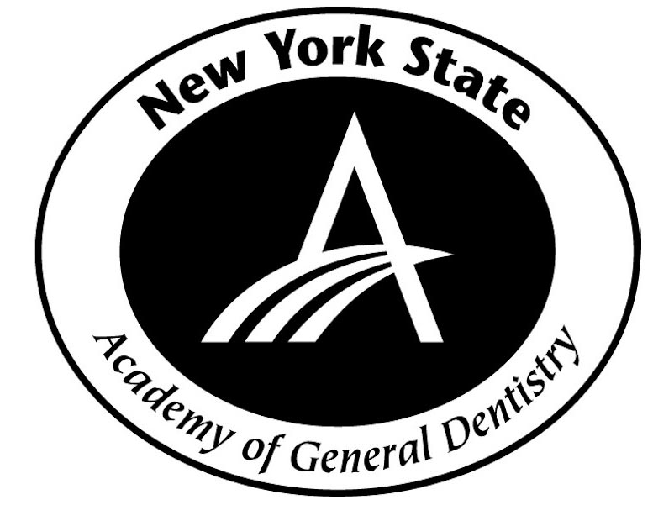

Registrant Information for NYSAGD Continuing Education Programs

Name of Course(s) Registering For: ________________________________

Full Name:___________________________________________

Billing Address: _________________________________________

City/State/Zip: _________________________________________

Telephone: _______________ Fax: ______________________

Email: _______________________________________________

Title (please circle) DDS DMD RDH RDA Other___________

FAGD: _______ MAGD: ________

Are you a current AGD member (please circle)? YES NO

AGD #__________________ADA #_________________________

Credit Card: (please circle one) Visa MC AMEX Discover

Card Number:___________________________ Exp Date__/__ Code_______
Located on back of Credit Card

Please fax this form to (718) 747-3355. If you have any questions, please call us at 718-747-3353.

An email or fax confirmation will be sent you upon completion of your registration.
Note: When you see your credit card bill it will say NYSAGD CE

